**Study on Application of Bayesian Networks in the Domain of Chest Diseases**

Team Member: Chinedu, Wei Chen

**Problem statement:**

吸烟与胸部疾病有着一定的因果关系，美国吸烟人数以及胸部疾病的发生率情况如何？文献介绍与真实情况是否相符？能否通过对病人情况咨询及合理的计算推理而得到某种疾病的发生率？这些情况有待于进行系统性调查研究。

A certain causal relationship exists between smoking and chest disease. How about the number of smokers in the United States and the incidence of breast disease? Does the number reported in literatures matching the actual situation? Is it possible to obtain the occurrence rate of some sort of disease by consulting the patient and arithmetic reasoning? These situations are subject to systematic investigation.

**Goals/Objective:**

一是通过调查（文献查阅及医院咨询）美国吸烟人数以及胸部疾病的发生率，建立有意义的**Bayesian Networks（BN）模型，服务于临床诊断**。

二是通过建立贝叶斯网络结构图并提供足够的条件概率值来进行合理的计算推理。

(1). To establish a meaningful Bayesian Networks (BN) model for clinical diagnosis by investigating the number of smoking and the incidence of breast diseases in the United States.

(2). To establish the BN structure diagram and provide sufficient conditional probability value for arithmetic reasoning.

**Methods**

1. 根据文献查阅的美国吸烟人数以及胸部疾病发生率的数据建立**Bayesian Networks（BN）模型1.**

2. 通过调查可能会发现实际病人的情况是另一种更加真实的数据，从而根据真实数据建立更加有意义的实用的BN模型2.

3. 建立贝叶斯网络结构图并提供足够的条件概率值

4. 进行合理的计算推理

1. Establish the Bayesian Networks (BN) model 1, according to the number of American smokers and the incidence of chest disease reported in literatures.

2. Establish a more meaningful and useful BN model 2, according to the real data by investigation.

3. Establish the BN structure diagram and provide sufficient conditional probability value.

4. Proceed the arithmetic reasoning according to Bayes formula and theorem

**Environment of Experiment: plan**

文献查阅及BN模型1的建立（实验室，Wei Chen）

实际情况调查及BN模型2的建立（医院，Chinedu）

其它工作（实验室，共同完成）

Literature review and the BN model 1(Lab. Wei Chen)

Actual situation survey and the BN model 2(Hospital. Chinedu)

Other works (Lab. Wei Chen and Chinedu)

**Expected Outcome and/or Contribution + others ?**

1. 建立有意义的Bayesian Networks（BN）模型，服务于临床诊断，such as

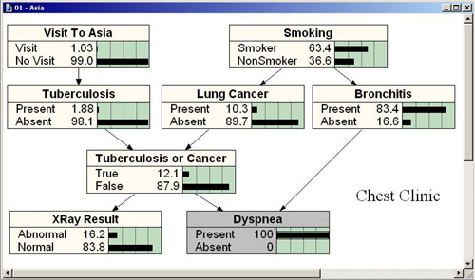

2. 利用贝叶斯公式和定理进行合理的因果计算，服务于临床诊断推理。

1. Establish a more meaningful and useful BN model and serve for the clinical diagnosis

2. By using the Bayes formula and theorem to serve for the clinical diagnostic inference